**Measuring Academic Performance in America’s Largest Cities**

**Research Proposal**

This project will examine 21 of America’s largest school districts – ranging in size from New York City to Cleveland. The goal is to determine which school characteristics matter in relation to standardized test scores. Performance will be measured through a school district’s average 4th and 8th grade math and reading scores in 2015. A variety of predictors will be examined through an Ordinary Least Squares (OLS) Regression, such as: funding, racial backgrounds, student-teacher ratio, percentage of students on reduced-price lunches, etc. The goal is to determine which district-level characteristics are important for standardized test scores and recommend any possible policy interventions, if applicable.

**About the Dataset**

The dataset contains two csv files, each from 2015 – the first from the Elementary/ Secondary Information System and the second from the National Assessment of Educational Progress. The first contains district-level financial information, i.e. local/state/federal revenues and expenditures for all schools district in America – about 18,680 school districts. The second contains assessment scores for the 21 school districts in America’s largest cities.

**School Funding**

The first step involved merging the dataset, using a district’s unique identifier, “Agency_ID”. This condensed the district funding file from ESIS down to the 21 largest cities. “TOTALREV” examines the sum of local, federal, and state funding. Dollars are in actual values. The lowest gross funding was $733M, while the most was $27B. “TLOCREV”, “TSTREV”, and “TFEDREV” examine local revenue, state revenue, and federal revenue for each district. The funding is also evaluated on a per-pupil basis, which is helpful when comparing larger school districts like New York, with smaller ones like Cleveland. On average, students are aggregated about $16,000 in America’s largest cities. This can range from $9,000 per student, up to almost $28,000.



**Academic Achievement**

The following tables describe some summary information from the National Assessment of Educational Progress, tracking students’ standardized math and reading scores. There were 21 cities evaluated, with the mean number of students at each school district being 197,549. The average math scores for 4th graders was 231, with the minimum school district scoring 205 on average, while the best school district scored 248, on average. AB and AP measures the percentage of a school districts’ students performing “Above Basic” or “Above Proficient”. For 4th grade math students, one school district had only 36% of their students perform above basic, while another school district had 87% score above basic. 4th grade reading scores averaged about 212, with a minimum of 186 and maximum of 230. 8th grade summary information is also available in the chart below.



The National Assessment of Education Progress also records demographic information on school districts in America’s largest cities. Of the 21 school districts, about 14% of students on average had a “Individualized Educational Plan”. 16% on average were enrolled in limited English proficiency programs. 73% of students were receiving free or discounted lunches – oftentimes used as a proxy for the percentage of students whose parents are at or below the poverty threshold. These school districts are predominantly black and Hispanic. Meanwhile the student to teacher ratio ranges from 11:1 to 23:1. I also included the total number of public schools and charters.



**Part I: Introductory Findings**

*What is the largest school district and how many students do they have?*

The largest school district is New York City Public Schools with 981,667 students

*What is the largest school district by total funding? By per-pupil funding? What is the smallest?*

The most total funding is in New York City at $27B. NYC also has the most funding per-pupil at $27,961 per student. The least amount of funding from this sample is in Cleveland at $733M. The least funding per pupil is in Duval County (FL) at $9,379 per student.

*Which school districts have the largest and smallest deficits?*

I created a new column to evaluate the difference between annual total revenues and annual total expenses. The largest budget surplus is in New York City at $2B. The largest budget deficit is in Los Angeles at -$643M.

*Which school districts have the best standardized scores? The worst?*

Charlotte has the highest 4th and 8th grade math scores on average. Hillsborough County, Florida and Miami Dade County have the highest 4th and 8th grade reading scores on average, respectively. All of the lowest scores came from Detroit’s public school system.

*Is there a correlation between 4th and 8th grade scores? Is there a correlation between math and reading scores?*

Math scores were highly correlated amongst 4th and 8th graders (r=0.87). Reading scores were also highly correlated across grades (r=0.92). Math and reading scores were highly correlated as well (r=0.91). This implies that school districts have little variation across subjects and grades in terms of standardized test performance.

*Is there any correlation between funding (TOTALREV_PUPIL) and academic scores?*

I created a new column that took the average of all test scores and grades for each school district. The correlation test found a negative relationship between increasing per-pupil funding and test scores (r=-0.33). This is particularly relevant for our research question, but will require further statistical tests.

**Part II: Visualizing the Data**

**Overview of Math and Reading Scores**

The charts below show the range of math scores for 4th and 8th grades. There’s a clear improvement in grade-level math scores from 2015.

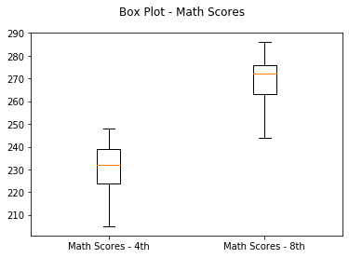 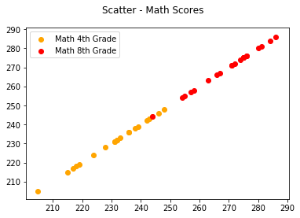

Similarily, the reading scores range from about 180 – 260 and show a clear improvement with age.

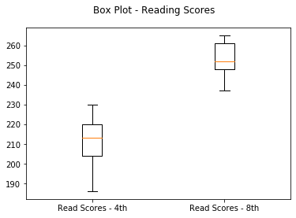 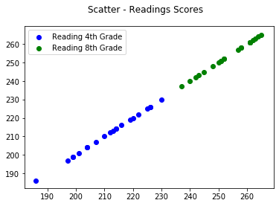

**Increasing Schools and Increasing Students**

For perspective, the chart below shows the relationship between a school district’s total number of students and total number of schools – obviously a clear positive relationship.

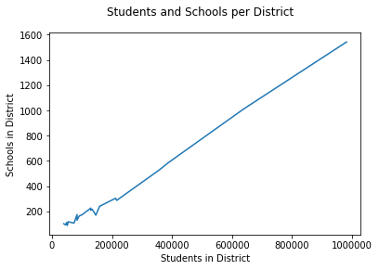

**Racial Background Amongst Students**

I also examined the racial backgrounds, on average, for all of the school districts in the sample. The schools are predominatly Hispanic and black, at 39% and 36% respectively.

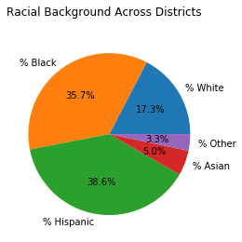

**Public School to Charter Ratio and Standardized Scores**

After creating a new column that evaluates the ratio of public schools to charter schools, I plotted the relationship with average standardized test scores. The chart indicates that there is a roughly positive relationship between more public schools/ less charter schools and standardized test performance. This intuitively makes sense. Charter schools usually take funding and high-performing students from public schools. Less charter schools means more funding and higher-performing students in public schools.

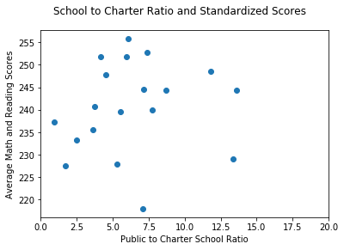

**Student to Teacher Ratio and Standardized Scores**

I also plotted the relationship between the student-teacher ratio and standardized average scores. One would expect a lower ratio to have improved math scores, but the data appears mostly random.

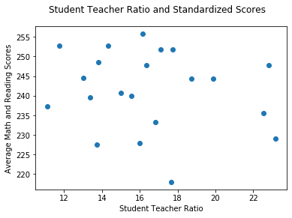

**School Funding and Standardized Scores**

Next I examined the relationship between school funding and standardized scores. The scatterplot below shows all sources – total, local, state, and federal revenues in comparison to standardized scores at the per-pupil level. The histogram on the right shows the frequencies of district-level total revenues per pupil – majority are less than $20,000 per student on average.

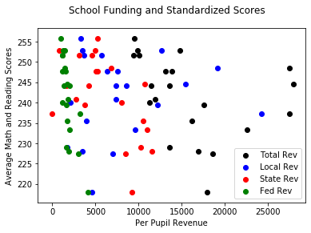 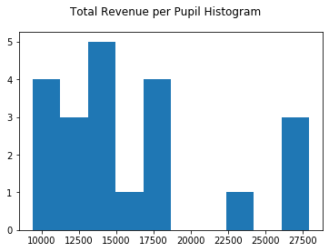

It’s hard to tell a relationship from the scatterplot, so I looked at each revenue source individually. Total revenue doesn’t show much connection with average standardized test scores. Increasing local revenue does appear to be connected with higher test scores, graphically. Higher state and federal revenues show a negative relationship with test scores. Oftentimes state and federal funding is used to compensate for low levels of local revenues. Obviously, this increased funding isn’t producing higher test scores, but its possible test scores would be even lower if it weren’t for this safety-net of non-local financing.

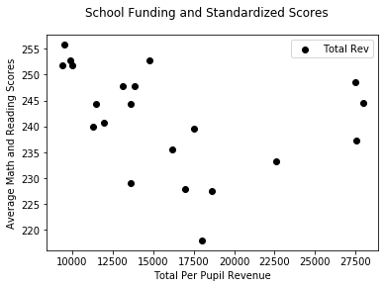 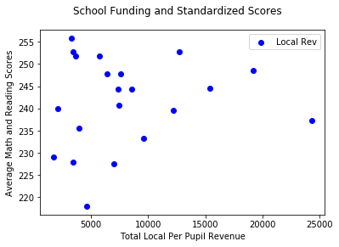

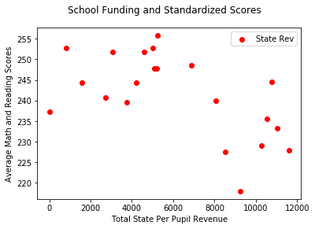 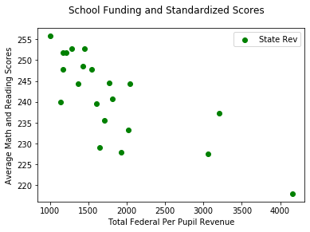

**Race and Standardized Scores**

I also examined the average racial identities of school districts to see if there was any relationship between race and academic performance. The results are mixed. There’s not much relationship with the percentage of Asian students and a district’s average scores. Meanwhile percentage of white students (in red) shows a positive relationship with test scores. Higher levels of black and Hispanic students (greater than 50%) show a decrease in a district’s average test scores.

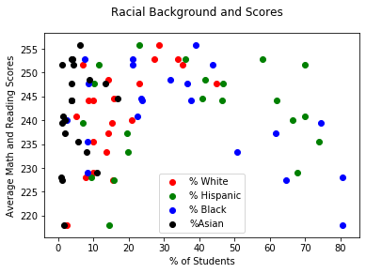

**Other School Characteristics and Standardized Scores**

Public schools often have more students that require special assistance. I evaluated this through three categories – percent of students with an IEP, percent of students on free/reduced-price lunches, and percent of students enrolled in limited-English programs. The chart below shows that an increase in students requiring discounted lunches results in lower average standardized scores – this is probably not causal, implying there’s other factors that are accounting for test performance. IEP and limited-English students are mostly clustered in the 15-20% range – there’s very little to interpret there.

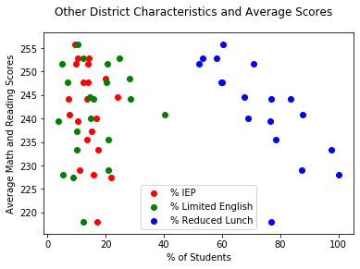

**Part III: Regression Analysis**

**Model 1 – Wealth**

*Average Scores = β1TLOCREV_PUPIL + β2%_Lunch + ϵ*

The first model evaluates two proxies for wealth – the total local revenues per pupil and percentage of students on free/reduced-price lunches. This model has an adjusted R2 of 0.493 and a statistically significant predictor in the “Lunch” variable at p<0.05. However, local revenues per pupil is not significant. For a 1% increase in a district’s composition of reduced-price lunch students, average standardized test scores decrease by half a point, controlling for local revenue per pupil.



**Model 2 – Funding**

*Average Scores = β1TLOCREV_PUPIL + β2TSTREV_PUPIL + β3TFEDREV_PUPIL + ϵ*

The next model examines the local, state, and federal funding on a per-pupil basis. Local and state revenues were not statistically significant, however federal funding shows a negative relationship with student test scores and is statistically significant. The adjusted R2 was 0.76, implying that this model captures about 76% of the variance in student test scores. Despite the increase in adjusted R2 from model 1, model 2 has a higher -2LogLikelihood, AIC and BIC. It’s difficult to assess the more precise model.



**Model 3 – Race**

*Average Scores = β1White + β2Black + β3Hispanic + β4Asian + β5Other + ϵ*

Model 3 examines the average ethnic background of the 21 school districts. Unfortunately, this model is unable to capture unique ethnic variation because the predictors are mutually exclusive.



**Model 4 – Other Characteristics**

*Average Scores = β1IEP + β2Limenglish + β3Pupil_Teacher + ϵ*

Model 4 examines a school district’s percent of students in Individualized Educational Programs, the percent of students enrolled in limited English programs, and the student-teacher ratio. This model was designed to capture unique support systems that districts provide their students. All of the predictors are not statistically significant and the model as a whole has an increased adjusted R2, -2LL, AIC, and BIC compared to Models 1 and 2.



**Model 5 – Final Model**

*Average Scores = β1TFEDREV_PUPIL + β2LUNCH + ϵ*

For the final model I took two of the strongest predictors – federal revenue per pupil and percent of students on free/reduced-price lunches. This model explains about 78% of the variance in average test scores given our dataset. It also has the lowest -2LL, AIC, and BIC amongst the five models. Increases in federal revenue per pupil and percent of students on discounted lunches shows a decrease in average standardized test scores in the district.



**Conclusion**

**Overview**

The goal of this report was to examine the relationship between standardized test performance and district-level characteristics. For funding, one would expect increases in total, state, and local revenues to improve standardized test scores, however this report points to the contrary in our largest cities. While state and local revenues are not statistically significant, increases in federal revenue actually show decreases in standardized average test scores in math and reading amongst 4th and 8th graders. Aspects like a district’s percent of students in limited-English programs, percent of students with an Individualized Educational Program (IEP), and the student-teacher ratio all failed to convey meaningful significance in relationship to academic scores. However, the percentage of a district’s students eligible for free or discounted lunches did show a statistically significant negative relationship with average test scores.

**Recommendations and Takeaways**

In future tests, it would be beneficial to have a larger data sample – potentially more cities and at the school-level, rather than district-level. Unfortunately, this analysis was limited by the number of cities that The Nation’s Report Card tracks. Additionally, it would be relevant to further explore the negative relationships that reduced-price lunches and federal funding have on standardized test scores. What omitted relevant variables are latent in these analyses? This study would benefit from a longitudinal analysis of federal funding. Has it increased or decreased over time and how does that impact test scores? Future studies may be able to find more relevant variables with the goal of improving academic performance in our nation’s inner cities.